**Overview**

This document presents three different implementations of a Multiple-Control X (MCX) gate with 5 control qubits and 1 target qubit. Each implementation optimizes for different metrics: circuit depth, quantum register width, or a balanced approach between the two.

**Minimized Depth:**

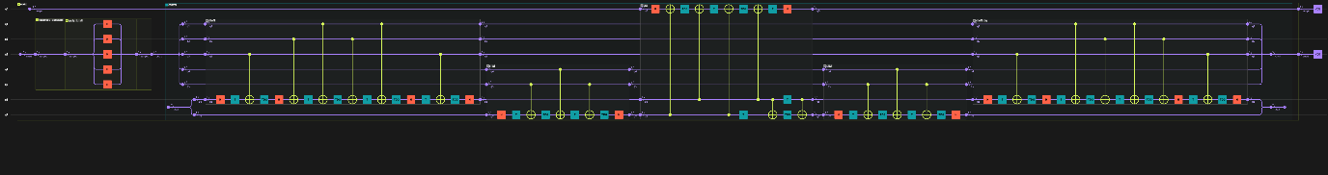

Depth: 34

Implementation details:

* Uses parallel decomposition of the multi-control operation
* Employs additional qubits to reduce sequential operations
* Achieves minimal circuit depth through parallel execution paths
* Trade-off: Requires more physical qubits to achieve the depth optimization

**Minimized Width:**

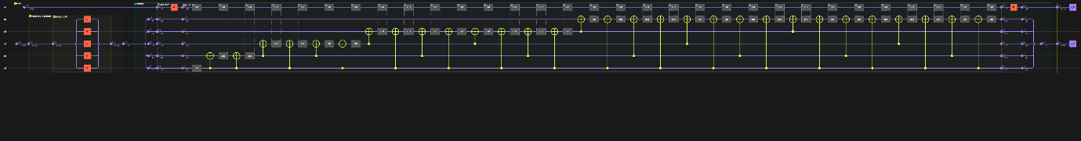

Width: 6

Implementation details:

* Uses basic decomposition into sequential Toffoli gates
* Requires no additional qubits
* Operates strictly on the input qubits (5 controls + 1 target)
* Trade-off: Increased circuit depth due to sequential operations

**Somewhere in between:**

Depth: 34 , Width: 8

Implementation details:

* Uses limited qubits for partial parallelization
* Achieves the same depth as the fully optimized version
* Reduces qubit requirements compared to depth-optimized version
* Trade-off: Good balance between resource requirements

**Resource Trade-offs**

1. Depth vs. Width:
   * Lower depth generally requires more qubits
   * Fewer qubits leads to increased circuit depth
   * The balanced implementation shows that optimal depth can be achieved with fewer resources than the maximum
2. Implementation Complexity:
   * Width-optimized version is simpler but slower
   * Depth-optimized version requires more complex control logic
   * Balanced version maintains complexity similar to depth-optimized but with fewer resources

Mcx with 20 cntrl qbits and 1 target:

Optimize depth:  
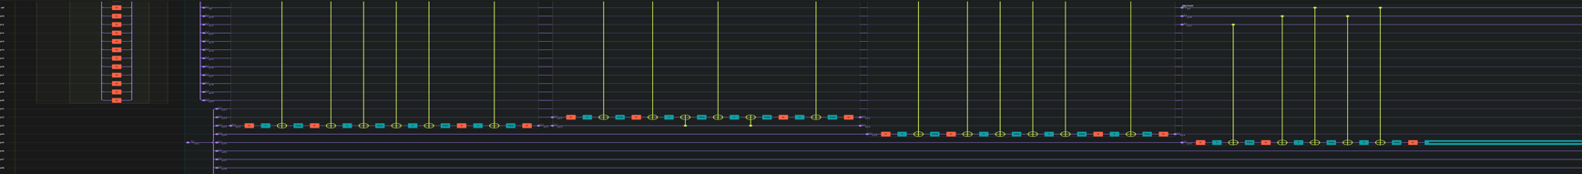

Depth:66 width 30

Optimize width:

Depth:1894 width 22